**5 - ServiceNow Lists and Filters**

**ServiceNow List view Interfaces -** The list view in ServiceNow is a user interface page in the content frame designed to display lists of records from a database table. It includes tools to easily sort, search, filter, and analyze list data quickly. You can also select an item from the list to see more details in a form view. There are several ways to access lists in ServiceNow :-

Application Navigator - Use links to different lists, such as navigating to "Incident All" in the navigator to open the incident table list interface.

Dot List Command - Enter the table name followed by ".list" in the application navigator filter to open the list interface for that table. For example:

*table.list* → Task Table

*incident.list* → Incident Table

*sys_user.list* → User Table

If you don't know the table name, use *sys_db_object.list* to see a database of all tables.

**Standard Paradigm** :**-**

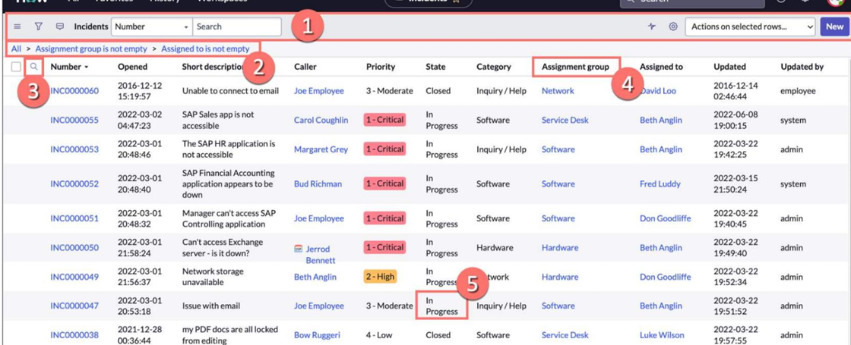

* Title Bar - It shows the list title and view name (if not on the default view), and includes a search box. Use the filter icon to create custom filters and the gear icon to personalize the list.

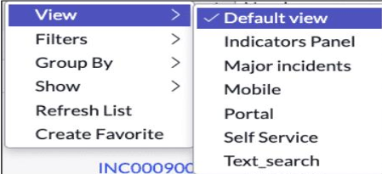

**List controls -** Click the list controls icon next to the filter icon for options to view and filter the entire list.

**Actions on Selected Rows -** Hover over and select any row (or use the Select All feature), then use the Actions on selected rows drop-down menu for options like adding records to a Visual Task Board (VTB).

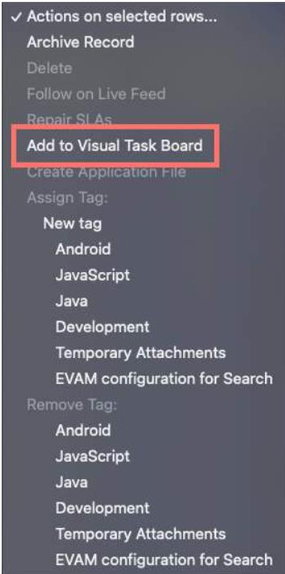

**Personalized list (gear icon) -** Customize a list by showing or hiding fields and changing the column order for the current user.

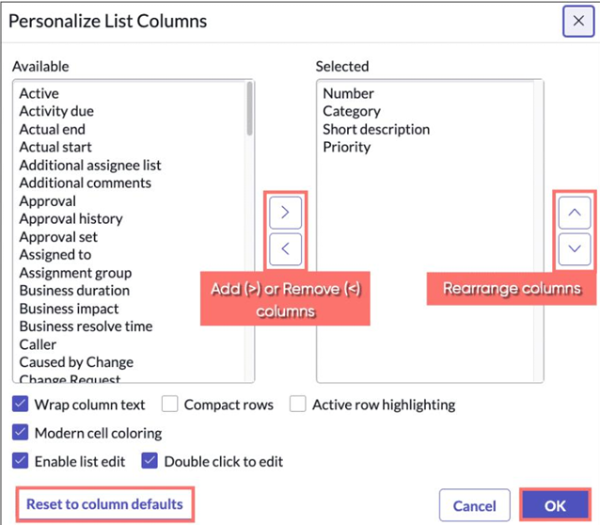

* Breadcrumbs - Provides quick filter navigation. Created by using the condition builder to apply filters to a list.
* Column Header Search - Allows searching within a specific column.
* Column Headers - Shows the title (field on a form) of each column.
* Field Values - Right-click on a field value for additional actions.

**Filter Conditions -** A filter is a set of conditions applied to a table list to isolate specific data. A filter condition consists of three components: field, operator, and value. You can add, remove, or edit filter conditions by clicking the Show/hide filter (funnel) icon.

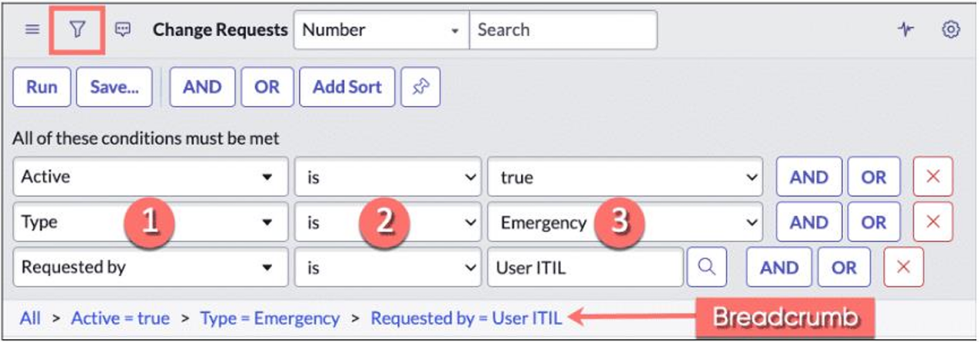

Field - A dropdown list based on the table and user access rights. It includes fields from related tables through dot-walking.

Operator - A dropdown list based on the field type. For example, in the incident table, the "greater than" operator doesn't apply to the Active field but does apply to the Priority field.

Value - Either a text entry field or a dropdown list, depending on the field type. For example, the Active field in the Incident table has a dropdown list with values like true, false, and empty, while the Short description field has a text entry field.

**Refresh List -** To enable list refresh, the Admin role is required to change a system property. Follow these steps:

1. Enter *sys_properties.list* in the Workspace filter navigator.
2. Search for *glide.lists.live_list_enabled* in the System Properties search bar.
3. Click the value column field and change the value to true.
4. Click the checkmark icon to save the change.

Once this is done, before the list refreshes, the refresh icon will show the number of changed records, and the list header will prompt you to check the refresh icon for updates. After refreshing, the affected rows will be displayed in bold text with an indicator badge.

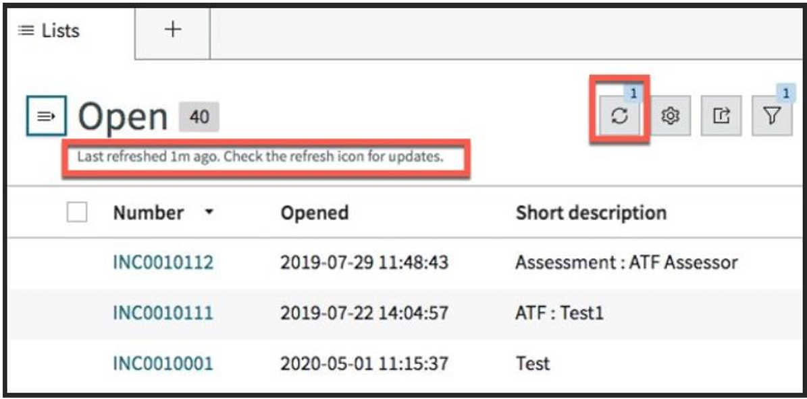

ANANYA CHOUDHARY